SIMATS ENGINEERING
ASSESSMENT TOOL 3

COURSE NAME: DESIGN AND ANALYSIS OF ALGORITHMS
COURSE CODE: CSA06

COURSE OUTCOME COVERED

CO 4 : Solve optimization problems using dynamic programming and greedy strategies.
Levels of Rubrics
(BL-4, BL-5)

Assessment Tool Weightage: 10%

QUESTIONS: 10 Total Marks: 50

Annexure A
Comparative Analysis

Code of Conduct:

I Sadhana V(192565042) (Name / Reg No) certify that this submission is my original work and that I have adhered to the guidelines specified for this assessment.

I understand that any violation of academic integrity rules will result in disciplinary action.

Signature of the student:
Annexure A

Comparative Analysis
Huffman Coding vs Container Loading – Greedy Comparison
1. PROBLEM
Greedy algorithms make the best local choice at each step to obtain an optimal or near-optimal solution.
This problem compares two greedy algorithms:
- Huffman Coding – selects the two symbols with the smallest frequencies and combines them.
- Container Loading – selects the items with the highest priority according to the loading criterion while respecting the container capacity.
The objective is to compare their selection criteria, optimality, complexity, and applications.
2. SOLUTION
A. Huffman Coding
Assume the following frequencies:
Symbol | Frequency
A | 5
B | 9
C | 12
D | 13
E | 16
F | 45
Greedy Selection
Select the two smallest frequencies repeatedly:
5 + 9 = 14
12 + 13 = 25
14 + 16 = 30
25 + 30 = 55
45 + 55 = 100
The Huffman tree produces prefix codes such as:
F → 0
C → 100
D → 101
A → 1100
B → 1101
E → 111
The frequently occurring symbol F receives a shorter code, while less frequent symbols receive longer codes.
Huffman Complexity
Using a min-priority queue:
- Time Complexity: O(n log n)
- Space Complexity: O(n)
Huffman Coding is optimal for constructing a prefix-free binary code with minimum weighted path length.

3. Container Loading
Assume a container has a capacity of 50 units.
Item | Weight | Value
A | 10 | 60
B | 20 | 100
C | 30 | 120
D | 15 | 80
For a greedy value-based strategy, items are considered according to their value/weight ratio.
Item | Weight | Value | Value/Weight
A | 10 | 60 | 6.0
B | 20 | 100 | 5.0
C | 30 | 120 | 4.0
D | 15 | 80 | 5.33
Greedy Selection
Order:
A → D → B → C
Capacity = 50
A = 10
D = 15
B = 20
----------------
Total = 45
Total value:
60 + 80 + 100 = 240
Therefore:
Selected Items = A, D, B
Total Weight = 45
Total Value = 240
For fractional container loading, the greedy value/weight strategy is optimal. For 0/1 container loading, however, a simple greedy strategy is not guaranteed to produce the globally optimal solution.
C PROGRAM
#include <stdio.h>
#include <stdlib.h>
#include <string.h>

struct Node
{
char data;
int freq;
struct Node *left;
struct Node *right;
};

struct Node* createNode(char data, int freq)
{
struct Node *newNode =
(struct Node*)malloc(sizeof(struct Node));

newNode->data = data;
newNode->freq = freq;
newNode->left = NULL;
newNode->right = NULL;

return newNode;
}

void swap(struct Node **a, struct Node **b)
{
struct Node *temp = *a;
*a = *b;
*b = temp;
}

void sortNodes(struct Node *nodes[], int n)
{
int i, j;

for (i = 0; i < n - 1; i++)
{
for (j = i + 1; j < n; j++)
{
if (nodes[i]->freq > nodes[j]->freq)
swap(&nodes[i], &nodes[j]);
}
}
}

struct Node* buildHuffman(char data[], int freq[], int n)
{
struct Node *nodes[20];
int i;

for (i = 0; i < n; i++)
nodes[i] = createNode(data[i], freq[i]);

while (n > 1)
{
sortNodes(nodes, n);

struct Node *left = nodes[0];
struct Node *right = nodes[1];

struct Node *parent =
createNode('$', left->freq + right->freq);

parent->left = left;
parent->right = right;

nodes[0] = parent;

for (i = 1; i < n - 1; i++)
nodes[i] = nodes[i + 1];

n--;
}

return nodes[0];
}

void printCodes(struct Node *root, int code[], int top)
{
int i;

if (root->left)
{
code[top] = 0;
printCodes(root->left, code, top + 1);
}

if (root->right)
{
code[top] = 1;
printCodes(root->right, code, top + 1);
}

if (!root->left && !root->right)
{
printf("%c : ", root->data);

for (i = 0; i < top; i++)
printf("%d", code[i]);

printf("\n");
}
}

int main()
{
char data[] = {'A', 'B', 'C', 'D', 'E', 'F'};
int freq[] = {5, 9, 12, 13, 16, 45};

int n = 6;
int code[20];

struct Node *root;

root = buildHuffman(data, freq, n);

printf("HUFFMAN CODING\n");
printf("----------------\n");

printf("Symbol Frequency\n");

for (int i = 0; i < n; i++)
printf(" %c %d\n", data[i], freq[i]);

printf("\nHuffman Codes:\n");

printCodes(root, code, 0);

return 0;
}
Container program
#include <stdio.h>

struct Item
{
int weight;
int value;
float ratio;
};

int main()
{
struct Item items[] =
{
{10, 60, 0},
{20, 100, 0},
{30, 120, 0},
{15, 80, 0}
};

int n = 4;
int capacity = 50;

int i, j;
int totalWeight = 0;
int totalValue = 0;

struct Item temp;

/* Calculate value/weight ratio */
for (i = 0; i < n; i++)
{
items[i].ratio =
(float)items[i].value / items[i].weight;
}

/* Sort according to value/weight ratio */
for (i = 0; i < n - 1; i++)
{
for (j = i + 1; j < n; j++)
{
if (items[i].ratio < items[j].ratio)
{
temp = items[i];
items[i] = items[j];
items[j] = temp;
}
}
}

printf("CONTAINER LOADING\n");
printf("------------------\n");

printf("Capacity = %d\n\n", capacity);

printf("Items selected:\n");

for (i = 0; i < n; i++)
{
if (totalWeight + items[i].weight <= capacity)
{
totalWeight += items[i].weight;
totalValue += items[i].value;

printf("Item %d: Weight = %d, Value = %d, Ratio = %.2f\n",
i + 1,
items[i].weight,
items[i].value,
items[i].ratio);
}
}

printf("\nTotal Weight = %d\n", totalWeight);
printf("Total Value = %d\n", totalValue);

return 0;
}
Output
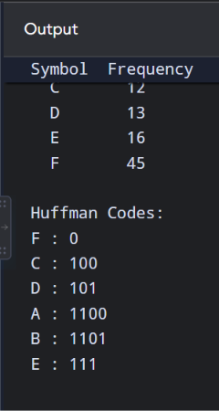
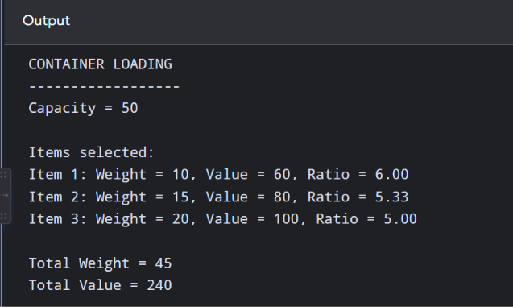
Coin Change Problem – Greedy vs Dynamic Programming
1. AIM
To write C programs for solving the Coin Change Problem using Greedy and Dynamic Programming approaches for coin denominations {1, 3, 4} and amount 6, and compare their results.

2. GREEDY APPROACH
Principle
The Greedy method always selects the largest possible coin first.
For amount 6:
Coins = 1, 3, 4

6 → 4
Remaining = 2

2 → 1
Remaining = 1

1 → 1
Remaining = 0
Therefore:
Coins selected = 4 + 1 + 1
Number of coins = 3
But the optimal solution is:
3 + 3 = 6
Number of coins = 2
Hence, Greedy fails to produce the optimal solution for this denomination set.
C PROGRAM – GREEDY
#include <stdio.h>

int main()
{
int coins[] = {1, 3, 4};
int n = 3;
int amount = 6;
int count = 0;
int i;

printf("COIN CHANGE USING GREEDY\n");
printf("-------------------------\n");

printf("Amount = %d\n", amount);
printf("Coins = 1 3 4\n\n");

/* Start from largest coin */
for (i = n - 1; i >= 0; i--)
{
while (amount >= coins[i])
{
printf("Selected coin: %d\n", coins[i]);

amount = amount - coins[i];
count++;
}
}

printf("\nNumber of coins = %d\n", count);

return 0;
}
OUTPUT
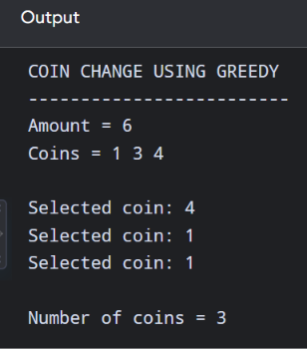
3. DYNAMIC PROGRAMMING APPROACH
Principle
Dynamic Programming calculates the minimum number of coins required for every amount from 0 to 6.
Recurrence:
The values are:
Amount | Minimum Coins
0 | 0
1 | 1
2 | 2
3 | 1
4 | 1
5 | 2
6 | 2
For amount 6:
3 + 3 = 6
Therefore, the minimum number of coins is 2.
C PROGRAM – DYNAMIC PROGRAMMING
#include <stdio.h>

#define INF 9999

int main()
{
int coins[] = {1, 3, 4};
int n = 3;
int amount = 6;

int dp[100];
int i, j;

/* Initialize DP array */
dp[0] = 0;

for (i = 1; i <= amount; i++)
dp[i] = INF;

/* Calculate minimum coins */
for (i = 1; i <= amount; i++)
{
for (j = 0; j < n; j++)
{
if (coins[j] <= i)
{
if (dp[i - coins[j]] + 1 < dp[i])
{
dp[i] = dp[i - coins[j]] + 1;
}
}
}
}

printf("COIN CHANGE USING DYNAMIC PROGRAMMING\n");
printf("---------------------------------------\n");

printf("Amount = %d\n", amount);
printf("Coins = 1 3 4\n\n");

printf("Minimum coins for each amount:\n");

for (i = 0; i <= amount; i++)
{
printf("Amount %d = %d coins\n", i, dp[i]);
}

printf("\nMinimum number of coins = %d\n", dp[amount]);

return 0;
}
OUTPUT
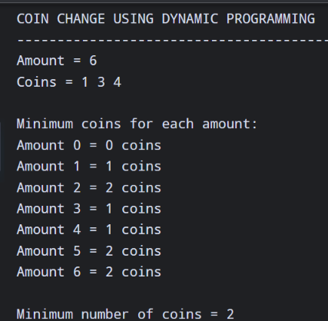
4. COMPARISON
Approach | Selected Coins | Number of Coins
Greedy | 4 + 1 + 1 | 3
Dynamic Programming | 3 + 3 | 2
Why does Greedy fail?
Greedy chooses the largest coin first:
6 → 4 + 1 + 1
This looks like a good choice locally, but it leaves an amount of 2, which requires two additional coins.
The better global choice is:
6 → 3 + 3
Thus, the local optimum (choosing 4) does not lead to the global optimum (using two 3s).

5. COMPLEXITY
Method | Time Complexity | Space Complexity
Greedy | O(n) approximately | O(1)
Dynamic Programming | O(amount × n) | O(amount)
Greedy is faster and uses less memory, but it is not always correct.
Dynamic Programming requires more computation and memory but guarantees the minimum number of coins for the general coin-change problem.
RESULT
Thus, the Coin Change Problem was successfully solved using both Greedy and Dynamic Programming.
For coins {1, 3, 4} and amount 6:
Greedy → 4 + 1 + 1 → 3 coins
DP → 3 + 3 → 2 coins
Therefore, Greedy fails for this case, while Dynamic Programming gives the optimal solution. Greedy is suitable when the coin system has the greedy-choice property, whereas Dynamic Programming should be preferred when the denominations are arbitrary and guaranteed optimality is required.

